MD Boilers Engineering Specification
MD 70T, MD 140T, MD 210T, MD 280T

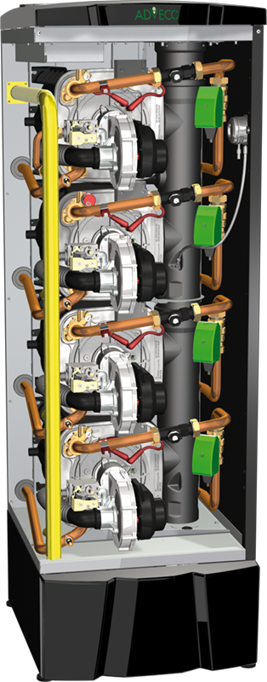
The boiler(s) shall be floor standing appliances with the capacity for multiple heat exchangers in a modular internal arrangement, with a minimum gross combustion efficiency of 96% and a seasonal space heating energy efficiency class of at least A at an efficiency of 91%. The unit shall be suitable for a working pressure of 11 bar and must have a footprint, inclusive of service clearances, not greater than 2,480mm height, 800mm width, and 2,396mm depth. The boiler(s) must be supplied with a parts and labour warranty of not less than 7 years.

The heat exchanger(s) within the boiler(s) must incorporate a continuous, non-welded run of AISI 316Ti titanium-stabilised stainless steel, with a large bore, three-pass design. The heat exchanger must be supplied with a warranty period of not less than 10 years. Each heat exchanger must be supplied with its own control board capable of load balancing.

The boiler(s) must feature an automatic gas/air pre-mix burner system that includes modulation of the fan and gas rate down to a minimum of 22% of the maximum input load. The appliance must present clean combustion rates with NO_{X} class 6 emission less than or equal to 34 mg/kWh and CO emission of less than or equal to 20 ppm. These figures must be verifiable by report from an approved test house. The burner component must be supplied with a warranty period of not less than 10 years.

The boiler(s) must have available a cascade controller compatible with cascade configurations of up to 2.24 MW or greater, able to perform maintenance self-check, 0-10 input, MODBUS communication, and alarm output.

The boiler(s) must feature a refillable acid condensate neutraliser internal to the appliance housing. All boiler(s) must include an internal flue gas non-return valve and be suitable for flue installation type B23.

