MD Wall-Hung Boilers Engineering Specification
MD 15, MD 24, MD 34, MD 60

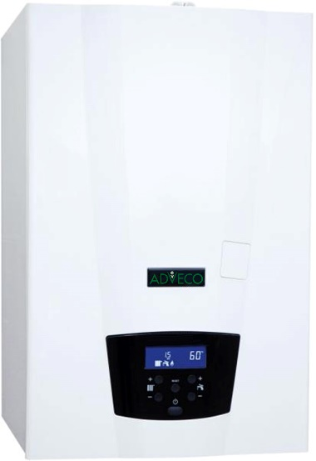
The boiler(s) shall be wall hung appliances with a minimum gross combustion efficiency of 96% and an energy efficiency class of at least A at a seasonal space heating energy efficiency of 91%. The boiler(s) must be available with a parts and labour warranty of not less than 7 years.

The heat exchanger within the boiler(s) must incorporate a continuous, non-welded run of AISI 316Ti titanium-stabilised stainless steel, with a large bore, three-pass design. The heat exchanger must be available with a warranty period of not less than 7 years.

The boiler(s) must feature an automatic gas/air pre-mix burner system that includes modulation of the fan and gas rate down to a minimum of 23% of the maximum input load. The appliance must present clean combustion rates with NO_{X} class 6 emission less than or equal to 31 mg/kWh and CO emission of less than or equal to 25 ppm. These figures must be verifiable by report from an approved test house. The burner component must be available with a warranty period of not less than 7 years. All boiler(s) must include an internal flue gas non-return valve and be suitable for flue installation type B23.

The boiler(s) must have available a cascade controller compatible with cascade configurations of up to 8 units, able to support 0-10 input and alarm output.

